**Subject:**

TC4002 - Analysis, Design and Construction of Software Systems

**Professor:**

Gerardo Padilla Zarate

**L5.1 - Development Exercises**

**Student:**

Juan Francisco Corral Stenner A00354823

For this assignment, we were requested to implement a couple of sorting algorithms and as bonus task to print their stats. Number of records, the time consumed in order to sort the list, start time, end time and the name of the used algorithm. A couple of learned lessons here, at least for me, are, in order to ease the test process, functions should focus in perform only one thing and only one thing. Input data should be passed as arguments rather generated inside them. Is a great practice to think how you will test your program before start coding.

Upon the results that I obtained, I conclude that the best algorithm is **quick sort** followed by **merge, heap** and **bubble sort**, in that order.

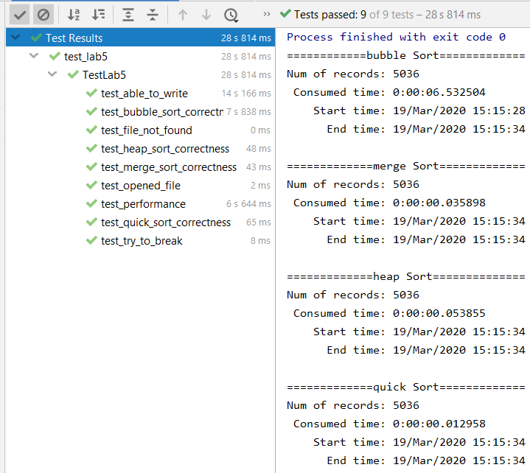

***Figure 1 – Performed tests and output***

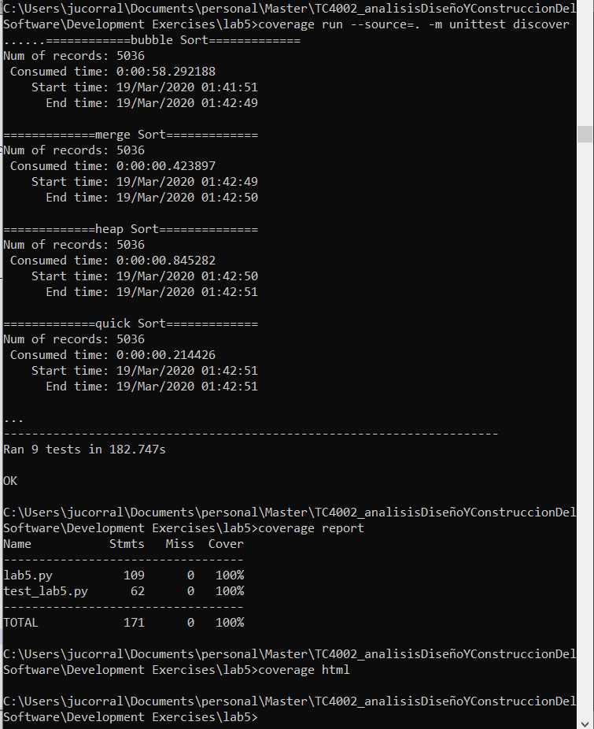

***Figure 2 – Coverage run***